IILM UNIVERSITY, GREATER NOIDA
Department of Computer Science & Engineering
SOFTWARE ENGINEERING LABORATORY
PRACTICAL FILE
Railway Reservation System
Name | Sumit Kumar
Roll No. | CS-23411584
Section | 3CSE1
Course | Software Engineering Lab
Submitted To | Ms. Yamini Singh

INDEX

Index
S.No. | Experiment Title | CO Mapping | Page No.
1 | SRS Document — IEEE Recommended Standards | CO1
2 | Use Case Diagram with Actors, Pre/Post Conditions | CO2, CO3
3 | Activity Diagram / Data Flow Diagram (DFD Levels 0,1,2) | CO2, CO3
4 | Class Diagram (Weak & Strong Classes) | CO2, CO3
5 | Sequence Diagram | CO2, CO3
6 | Collaboration Diagram | CO2, CO3
7 | State Chart Diagram | CO2, CO3
8 | Component Diagram | CO2, CO3
9 | Forward Engineering in Python (Model to Code) | CO3
10 | Reverse Engineering in Python (Code to Model) | CO3

Practical 1: SRS Document

Practical No. 1
Aim | Prepare a Software Requirements Specification (SRS) document in line with IEEE recommended standards.

1. Introduction
1.1 Purpose
The purpose of this document is to provide a detailed description of the Railway Reservation System. It outlines the functional and non-functional requirements to ensure an automated, efficient, and error-free environment for booking train tickets, managing schedules, and handling passenger data.
1.2 Scope
The system encompasses all aspects of railway ticketing, including:
- Searching for trains between specific stations.
- Checking real-time seat availability and fare details.
- Electronic booking and PNR (Passenger Name Record) generation.
- Ticket cancellation and automated refund calculations.
- Administrative tools for managing train routes and timings.
1.3 Definitions, Acronyms, and Abbreviations
Term | Definition
PNR | Passenger Name Record — unique 10-digit ID per booking
SRS | Software Requirements Specification
AC | Air Conditioned (train class)
ACID | Atomicity, Consistency, Isolation, Durability
SSL | Secure Sockets Layer — encryption protocol
UI | User Interface
API | Application Programming Interface
WL | Waitlist — booking status when no seat available
RAC | Reservation Against Cancellation

2. System Overview
2.1 Product Perspective
The Railway Reservation System is a centralized web-based application designed to replace manual ticket counter processes. It serves as a bridge between the Railway Department's database and the end-user, providing a 24/7 accessible platform for travel planning and ticket management.
2.2 Target Users
- Passengers: General public looking to search, book, or cancel tickets.
- Railway Administrators: Staff responsible for updating train schedules, adding new routes, and managing seat quotas.
- Travel Agents: Authorized third-party entities performing bulk bookings for clients.
- System Maintenance Team: Technical staff ensuring uptime and security of the database.

3. Functional Requirements
3.1 User Management, Search and Inquiry
- Registration/Login: Secure accounts for users to save passenger profiles and view booking history.
- Profile Management: Capability to update contact details and preferences.
- Train Schedule: Ability to search trains by train number, name, or source/destination stations.
- Seat Availability: Real-time checking of vacant seats across different classes (1AC, 2AC, 3AC, Sleeper).
- Fare Inquiry: Calculation of total fare including base price, taxes, and concessions.
3.2 Booking, Reservation, Cancellation and Refunds
- Passenger Entry: Input for name, age, gender, and berth preference.
- PNR Generation: Automatic generation of a unique 10-digit PNR upon successful payment.
- E-Ticket Generation: Downloadable PDF ticket with QR code verification.
- Cancellation Module: Allows users to cancel confirmed or waitlisted tickets.
- Refund Logic: Automated refund calculation based on time before departure and railway policies.

4. Non-Functional Requirements
4.1 Performance
- The system must handle at least 10,000 concurrent users during peak Tatkal hours.
- Search results must be generated within 2 seconds of the request.
4.2 Security
- Encryption of all user passwords and payment information using SSL/TLS.
- Role-based access control to ensure only Admins can modify train schedules.
4.3 Reliability
- The database must ensure ACID properties to prevent double-booking of the same seat.
- Automated daily backups of all transaction and user data.
4.4 Availability
- The system should maintain 99.9% uptime, available 24 hours a day, 7 days a week.

5. System Architecture
The Railway Reservation System follows a 3-Tier Architecture:
- Presentation Tier (Frontend): Developed using React.js or HTML5/CSS3. Provides the User Interface for browsers and mobile devices.
- Application Tier (Backend): Developed using Python (Django/FastAPI) or Java (Spring Boot). Handles business logic such as seat allocation algorithms and PNR generation.
- Data Tier (Database): Utilizes PostgreSQL or MySQL. Stores master data for trains, stations, user accounts, and transaction logs.

Result
The SRS document for the Railway Reservation System has been successfully prepared in line with IEEE recommended standards, covering all functional requirements, non-functional requirements, and system architecture details.

Practical 2: Use Case Diagram

Practical No. 2
Aim | Draw the Use Case Diagram and specify the role of each actor. Also state the precondition, post condition and function of each use case.

Theory
A Use Case Diagram is a type of behavioral UML diagram that represents the interactions between actors (users or external systems) and use cases (functionalities). It provides a high-level view of the system and helps in identifying the actors, their goals, and the system's responses.

Actors and Their Roles
Actor | Role
Passenger | Primary actor. Registers, logs in, searches trains, books/cancels tickets, checks PNR status, and makes payments.
Railway Administrator | Manages train schedules, adds/modifies routes, updates seat quotas and pricing.
Travel Agent | Performs bulk bookings on behalf of passengers; has elevated booking privileges.
Payment Gateway | External system that processes financial transactions securely during booking or refund.
Database Server | External system that stores and retrieves all application data including user info, trains, and transactions.

Use Case Diagram
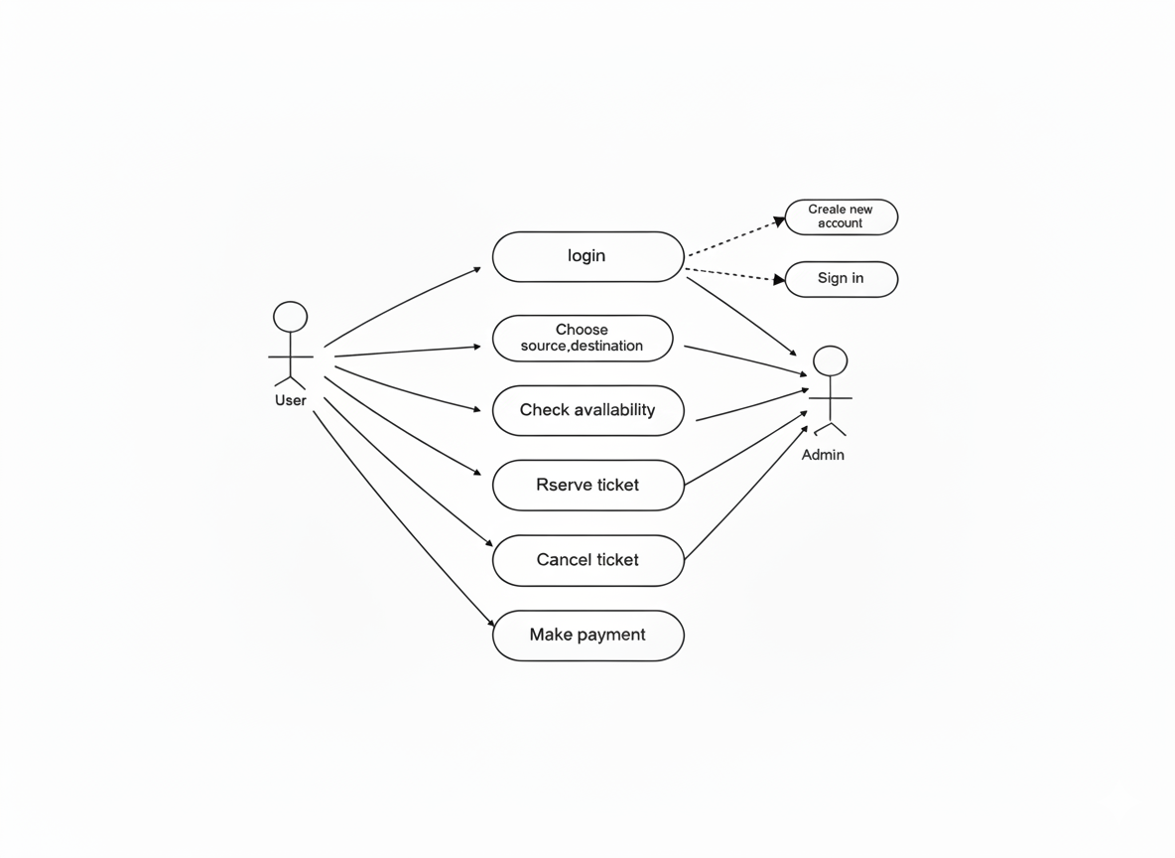

Use Case Specifications
Use Case | Actor(s) | Precondition | Post Condition | Description
Register / Login | Passenger, Travel Agent | User has internet access; system is online | User is authenticated and session is created | User creates an account or logs in with credentials to access booking features.
Search Train | Passenger, Travel Agent | User is logged in; source & destination provided | List of available trains and schedules displayed | System queries database for trains matching source, destination and date.
Check Seat Availability | Passenger, Travel Agent | Train is selected by user | Available seats and classes shown to user | Displays real-time seat count for each class (1AC, 2AC, 3AC, Sleeper, General).
Book Ticket | Passenger, Travel Agent | Seat available; user logged in; payment info ready | PNR generated; e-ticket issued; seat reserved in DB | User enters passenger details, selects class/berth, proceeds to payment.
Make Payment | Passenger, Pmt Gateway | Booking form is complete | Payment confirmed; booking is finalized | Securely processes payment via Payment Gateway using SSL.
Cancel Ticket | Passenger | User has a confirmed booking; cancellation window is open | Seat released; refund initiated as per railway policy | User cancels ticket; system calculates refund based on time before departure.
Check PNR Status | Passenger | User has a valid PNR number | Current booking status displayed (Confirmed / WL / RAC) | System retrieves booking status from database using PNR.
Manage Train Schedule | Railway Administrator | Admin is authenticated with admin role | Train schedule updated successfully in database | Admin can add, edit, or delete train routes, timings, and seat configurations.

Result
The Use Case Diagram for the Railway Reservation System has been successfully drawn. All actors and their interactions with the system have been identified and documented with preconditions, post conditions, and functional descriptions.

Practical 3: Activity Diagram / DFD

Practical No. 3
Aim | Draw the Activity Diagram and Data Flow Diagram (DFD Levels 0, 1, 2) for the Railway Reservation System.

Part A — Activity Diagram
An Activity Diagram is a behavioral UML diagram that models the workflow or business logic of the system using activities, decisions, forks, joins, and swimlanes. It shows the flow of control from one activity to the next.
The diagram below uses swimlanes for Passenger, System/App Server, Payment Gateway, and Database. It covers the full ticket booking workflow from login to e-ticket receipt.
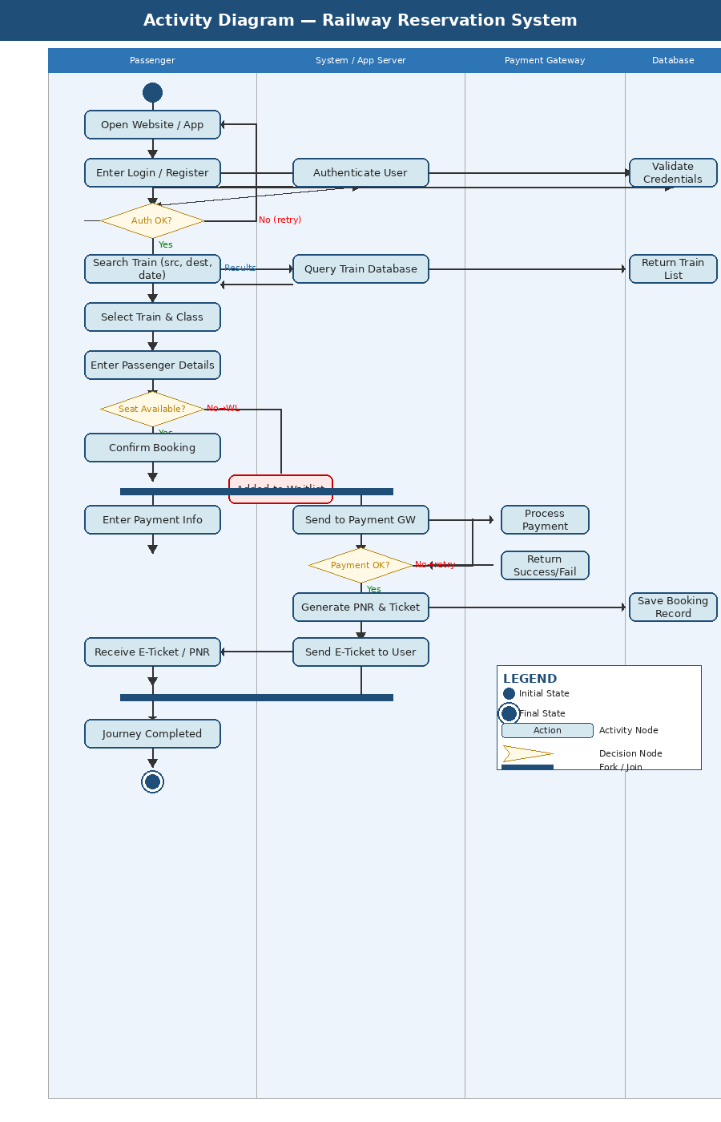

Part B — DFD Level 0 (Context Diagram)
The context diagram shows the Railway Reservation System as a single process interacting with external entities: Passenger, Railway Administrator, Payment Gateway, and Train Database.
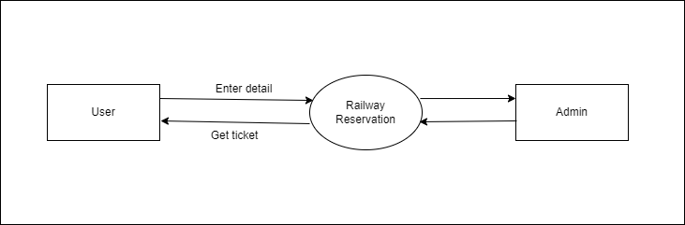

Part C — DFD Level 1
Level 1 decomposes the main process into sub-processes: User Authentication, Train Search, Booking & Reservation, Payment Processing, Cancellation & Refund, and Admin Management.
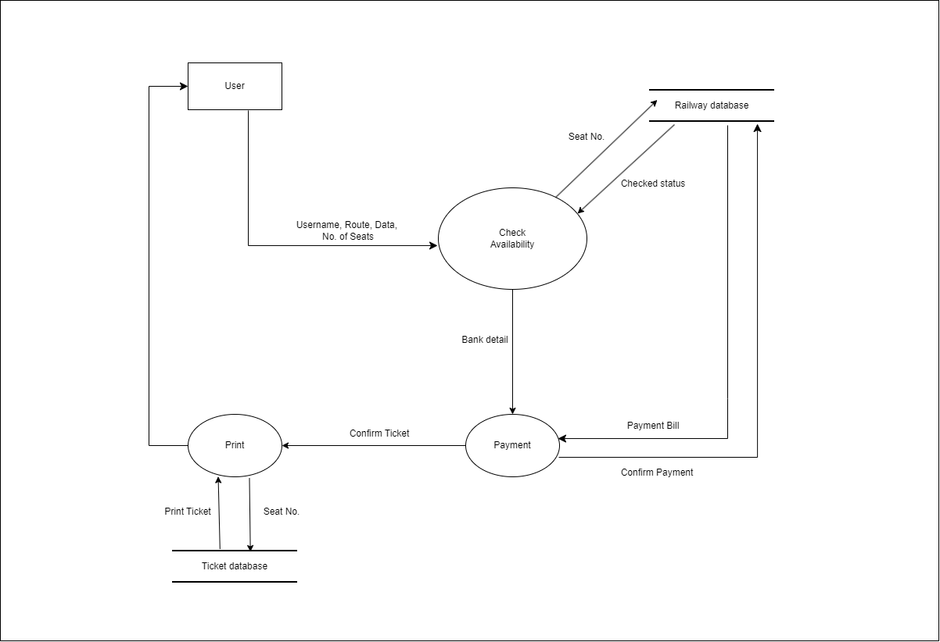

Part D — DFD Level 2
Level 2 further decomposes the Booking & Reservation process to show detailed data flows between passenger detail entry, seat allocation, PNR generation, and e-ticket creation.
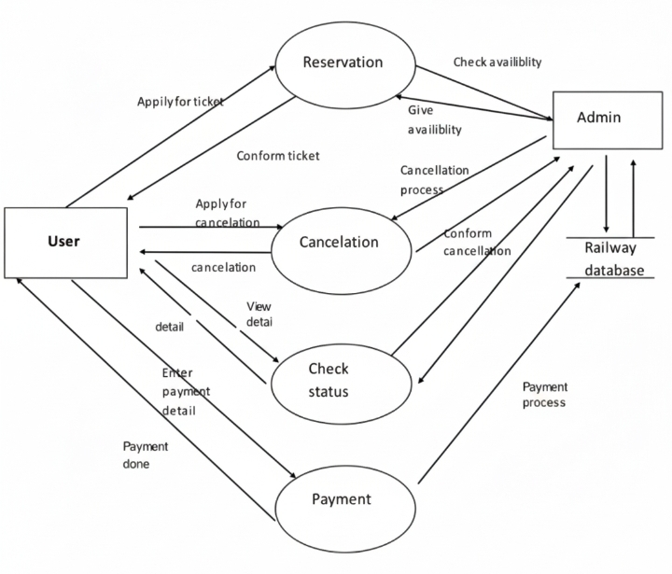

Result
The Activity Diagram and Data Flow Diagrams at Levels 0, 1, and 2 have been successfully drawn for the Railway Reservation System, illustrating the complete workflow and data flow from user interaction to database operations.

Practical 4: Class Diagram

Practical No. 4
Aim | Identify the classes, classify them as weak and strong classes, and draw the Class Diagram.

Theory
A Class Diagram is a structural UML diagram that describes the static structure of the system by showing classes, their attributes, methods, and the relationships between them. A strong (independent) class exists on its own, while a weak (dependent) class depends on another class for its existence.

Class Classification
Class Name | Type | Key Attributes
User | Strong | userId, name, email, password, phone
Train | Strong | trainNo, trainName, source, destination, totalSeats
Station | Strong | stationCode, stationName, city
Schedule | Strong (Association) | scheduleId, departureTime, arrivalTime
Seat | Weak (depends on Train) | seatId, seatNo, classType, status
Booking | Weak (depends on User & Train) | bookingId, bookingDate, status, totalFare
Passenger | Weak (depends on Booking) | passengerId, name, age, gender, berthPref
Payment | Weak (depends on Booking) | paymentId, amount, mode, status, transactionId
Ticket | Weak (depends on Booking) | ticketId, PNR, issueDate, qrCode
Cancellation | Weak (depends on Booking) | cancelId, cancelDate, refundAmount

Class Diagram
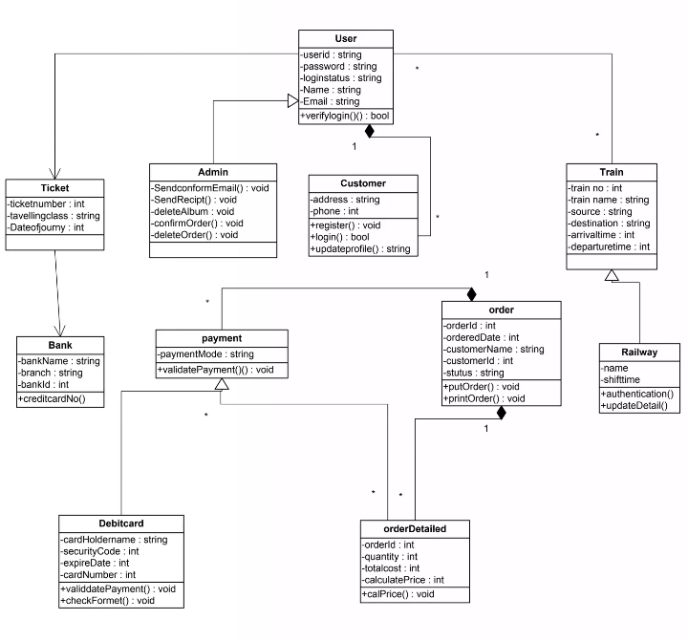

Result
The classes for the Railway Reservation System have been identified and classified as strong (independent) and weak (dependent). The class diagram has been successfully drawn depicting all classes, their attributes, and relationships including associations, aggregations, and dependencies.

Practical 5: Sequence Diagram

Practical No. 5
Aim | Draw the Sequence Diagram for the Railway Reservation System.

Theory
A Sequence Diagram is a type of interaction UML diagram that shows how objects communicate with each other in a time-ordered sequence. It illustrates the order of messages exchanged between lifelines (objects/components) for a particular scenario or use case.

Scenario: Ticket Booking by a Passenger
The sequence diagram illustrates the following steps:
- Passenger logs in through the UI and is authenticated by the User Management module.
- Passenger searches for a train; the system queries the Train Database and returns results.
- Passenger selects a train and checks seat availability; the Reservation module queries Seat records.
- Passenger fills in passenger details and proceeds to payment.
- The Payment Gateway processes the transaction and returns a success/failure response.
- On success, the Booking module generates a PNR and creates an e-Ticket.
- The system sends a confirmation with the e-Ticket to the Passenger.

Sequence Diagram
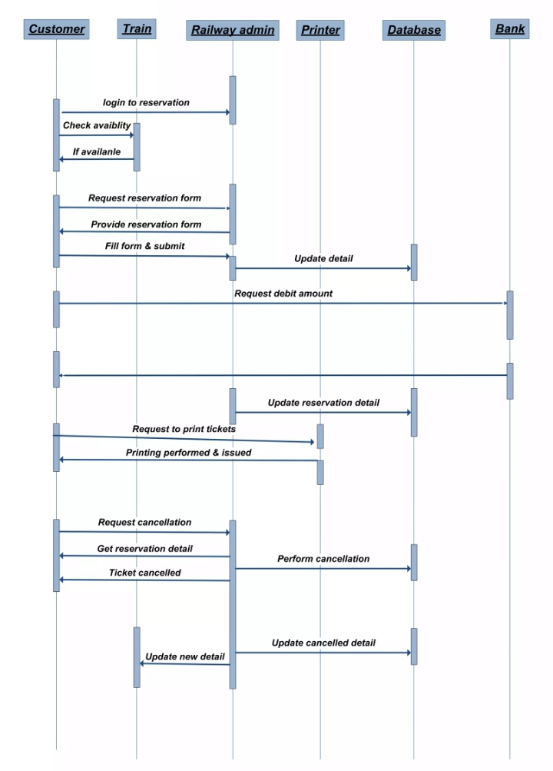

Result
The Sequence Diagram for the ticket booking use case has been successfully drawn, clearly depicting the time-ordered interaction between the Passenger, User Interface, Application Server, Database, and Payment Gateway.

Practical 6: Collaboration Diagram

Practical No. 6
Aim | Draw the Collaboration Diagram for the Railway Reservation System.

Theory
A Collaboration Diagram (Communication Diagram in UML 2.x) depicts interactions between objects in a network topology, focusing on the structural organisation of objects and the messages passed between them. Unlike Sequence Diagrams, Collaboration Diagrams use numbered messages to show the order of interaction.

Collaboration Diagram
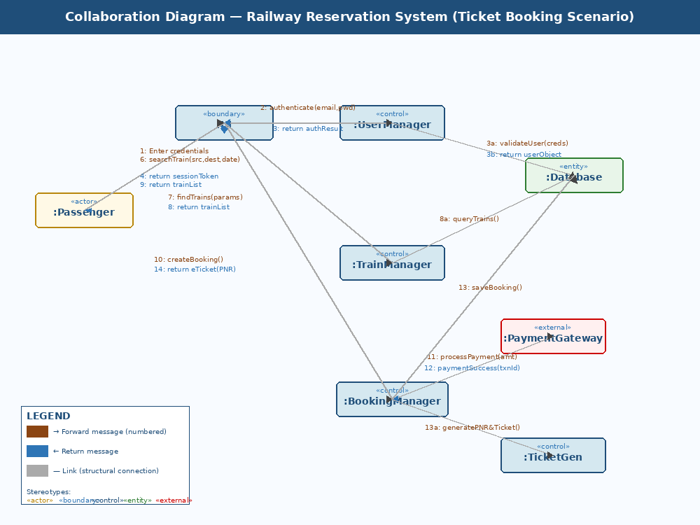

Message Sequence Table
Msg No. | Sender | Receiver | Message / Action
1 | Passenger | UI | Enter credentials & submit login
2 | UI | UserManager | authenticate(email, password)
3a | UserManager | Database | validateUser(credentials)
3b | Database | UserManager | return userObject
4 | UserManager | UI | return sessionToken
5 | Passenger | UI | searchTrain(src, dest, date)
6 | UI | TrainManager | findTrains(src, dest, date)
7a | TrainManager | Database | queryTrains(params)
7b | Database | TrainManager | return trainList
8 | TrainManager | UI | return trainList
9 | UI | BookingManager | createBooking(trainId, passengerData)
10 | BookingManager | PaymentGateway | processPayment(amount, mode)
11 | PaymentGateway | BookingManager | paymentSuccess(transactionId)
12 | BookingManager | Database | saveBooking() & generatePNR()
13 | BookingManager | TicketGen | generateETicket(bookingId)
14 | BookingManager | UI | return eTicket(PNR)

Result
The Collaboration Diagram for the Railway Reservation System ticket booking scenario has been successfully drawn, showing all object interactions with numbered message sequences.

Practical 7: State Chart Diagram

Practical No. 7
Aim | Draw the State Chart Diagram for the Railway Reservation System.

Theory
A State Chart Diagram (State Machine Diagram) is a behavioral UML diagram that models the dynamic behavior of an object by showing its states and the transitions between them triggered by events or conditions. It is particularly useful for objects with complex lifecycle behavior.

States of the Booking Object
State | Description
Idle | Initial state; no booking initiated.
Searching | User has entered search parameters; system is querying trains.
Train Selected | User has selected a specific train and class.
Filling Details | User is entering passenger details and berth preferences.
Pending Payment | Booking form submitted; awaiting payment confirmation.
Payment Processing | Payment request sent to Payment Gateway.
Payment Failed | Payment Gateway returned a failure; user can retry.
Confirmed | Payment successful; PNR generated; e-ticket issued.
Waitlisted (WL) | Seats not available; booking added to waitlist queue.
RAC | Reservation Against Cancellation; partial confirmation granted.
Cancellation Requested | User has initiated ticket cancellation.
Refund Processing | Cancellation approved; refund amount is being calculated.
Cancelled | Final state; booking cancelled, refund initiated.
Journey Completed | Final state; passenger has undertaken the journey successfully.

State Chart Diagram
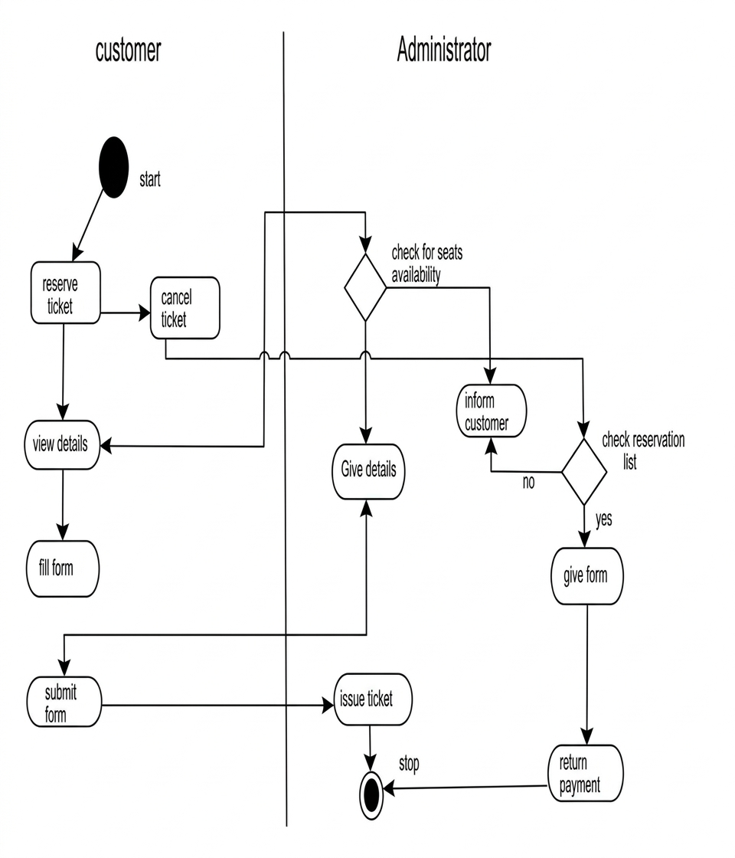

Result
The State Chart Diagram for the Booking object in the Railway Reservation System has been successfully drawn, showing all possible states and the transitions between them triggered by user actions and system events.

Practical 8: Component Diagram

Practical No. 8
Aim | Draw the Component Diagram for the Railway Reservation System.

Theory
A Component Diagram is a structural UML diagram that shows the organisation and dependencies among software components. It depicts how components are wired together to form larger systems and illustrates the provided and required interfaces.

Component Diagram
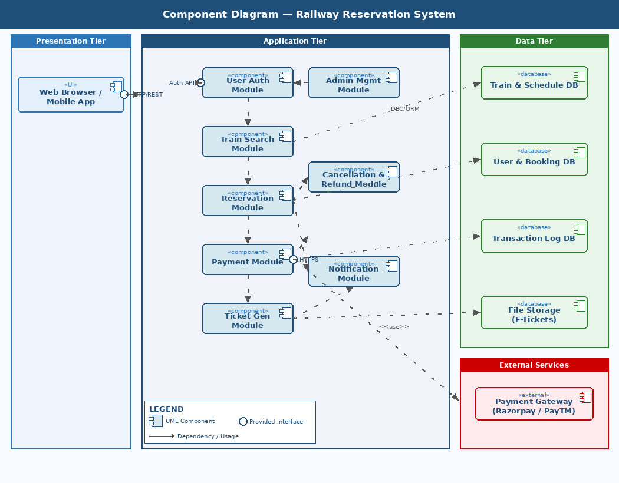

Components and Their Responsibilities
Component | Tier | Responsibility
Web Browser / Mobile App | Presentation | UI rendered with HTML5/CSS3/React.js
User Auth Module | Application | Registration, login, session & role-based access
Train Search Module | Application | Query train data, filter by route and date
Reservation Module | Application | Seat allocation, waitlisting, PNR generation
Payment Module | Application | Integrate with Payment Gateway for transactions
Ticket Gen Module | Application | Create e-Ticket PDF with QR code after payment
Cancellation & Refund Mod. | Application | Process cancellations and compute refunds
Admin Management Module | Application | Manage trains, routes, schedules via admin role
Notification Module | Application | Send SMS/email confirmations and reminders
Train & Schedule DB | Data | PostgreSQL: trains, routes, schedules, seats
User & Booking DB | Data | Stores user profiles and booking history
Transaction Log DB | Data | Audit trail of all payments and cancellations
File Storage (E-Tickets) | Data | Stores generated PDF e-tickets
Payment Gateway | External | Third-party service (Razorpay/PayTM) for payments

Result
The Component Diagram for the Railway Reservation System has been successfully drawn, illustrating the three-tier architecture and all software components with their interfaces and dependencies.

Practical 9: Forward Engineering

Practical No. 9
Aim | Perform Forward Engineering in Python — Model to Code conversion for the Railway Reservation System.

Theory
Forward Engineering is the process of converting a high-level design model (such as a Class Diagram or UML model) into implementation code. It translates design artifacts — classes, attributes, methods, and relationships — into actual source code.

Python Code — Generated from Class Diagram
railway_reservation.py
from datetime import datetime
import uuid

# ===================== Strong Classes =====================

class User:
"""Strong class representing a registered user."""
def __init__(self, name: str, email: str, password: str, phone: str):
self.user_id = str(uuid.uuid4())
self.name = name
self.email = email
self._password = password # stored as hash in production
self.phone = phone

def login(self, email: str, password: str) -> bool:
return self.email == email and self._password == password

def update_profile(self, name=None, phone=None):
if name: self.name = name
if phone: self.phone = phone

def __repr__(self):
return f"User({self.name}, {self.email})"

class Train:
"""Strong class representing a train."""
def __init__(self, train_no: str, train_name: str,
source: str, destination: str, total_seats: int):
self.train_no = train_no
self.train_name = train_name
self.source = source
self.destination = destination
self.total_seats = total_seats
self.seats = [] # list of Seat objects

def get_available_seats(self, seat_class: str) -> int:
return sum(1 for s in self.seats
if s.class_type == seat_class
and s.status == "AVAILABLE")

def __repr__(self):
return f"Train({self.train_no} - {self.train_name})"

class Station:
"""Strong class representing a railway station."""
def __init__(self, code: str, name: str, city: str):
self.station_code = code
self.station_name = name
self.city = city

def __repr__(self):
return f"Station({self.station_code} - {self.station_name})"

# ===================== Weak Classes =====================

class Seat:
"""Weak class — existence depends on Train."""
def __init__(self, seat_no: str, class_type: str, train: Train):
self.seat_id = str(uuid.uuid4())
self.seat_no = seat_no
self.class_type = class_type # 1AC | 2AC | 3AC | SL | GEN
self.status = "AVAILABLE"
self.train = train # owning Train object

def reserve(self):
if self.status != "AVAILABLE":
raise ValueError("Seat is not available.")
self.status = "RESERVED"

def release(self):
self.status = "AVAILABLE"

def __repr__(self):
return f"Seat({self.seat_no}, {self.class_type}, {self.status})"

class Passenger:
"""Weak class — existence depends on Booking."""
def __init__(self, name: str, age: int,
gender: str, berth_pref: str):
self.passenger_id = str(uuid.uuid4())
self.name = name
self.age = age
self.gender = gender
self.berth_pref = berth_pref # LOWER | MIDDLE | UPPER

def __repr__(self):
return f"Passenger({self.name}, {self.age}, {self.gender})"

class Payment:
"""Weak class — existence depends on Booking."""
def __init__(self, amount: float, mode: str, booking):
self.payment_id = str(uuid.uuid4())
self.amount = amount
self.mode = mode # CARD | UPI | NET_BANKING
self.status = "PENDING"
self.transaction_id = None
self.booking = booking

def process(self) -> bool:
# In production: call Payment Gateway API here
self.transaction_id = "TXN" + str(uuid.uuid4())[:8].upper()
self.status = "SUCCESS"
return True

def __repr__(self):
return f"Payment({self.payment_id}, {self.amount}, {self.status})"

class Booking:
"""Weak class — existence depends on User and Train."""
def __init__(self, user: User, train: Train,
journey_date: str, seat_class: str):
self.booking_id = str(uuid.uuid4())
self.booking_date = datetime.now().strftime("%Y-%m-%d %H:%M:%S")
self.status = "PENDING"
self.user = user
self.train = train
self.journey_date = journey_date
self.seat_class = seat_class
self.passengers = []
self.payment = None
self.pnr = None

def add_passenger(self, passenger: Passenger):
self.passengers.append(passenger)

def confirm_booking(self):
self.status = "CONFIRMED"
self.pnr = "PNR" + str(uuid.uuid4().int)[:10]

def cancel(self):
self.status = "CANCELLED"
return Cancellation(self)

def __repr__(self):
return f"Booking({self.booking_id}, PNR={self.pnr}, {self.status})"

class Ticket:
"""Weak class — existence depends on Booking."""
def __init__(self, booking: Booking):
self.ticket_id = str(uuid.uuid4())
self.pnr = booking.pnr
self.issue_date = datetime.now().strftime("%Y-%m-%d")
self.booking = booking
self.qr_code = f"QR_{self.pnr}"

def generate_pdf(self) -> str:
# In production: use reportlab to generate PDF
return f"E-Ticket PDF for PNR {self.pnr} generated successfully."

def __repr__(self):
return f"Ticket(PNR={self.pnr})"

class Cancellation:
"""Weak class — existence depends on Booking."""
def __init__(self, booking: Booking):
self.cancel_id = str(uuid.uuid4())
self.cancel_date = datetime.now().strftime("%Y-%m-%d %H:%M:%S")
self.booking = booking
self.refund_amount = self._calculate_refund()

def _calculate_refund(self) -> float:
# Simplified refund logic (75% refund)
fare = self.booking.payment.amount if self.booking.payment else 0
return fare * 0.75

def __repr__(self):
return f"Cancellation({self.cancel_id}, Refund=Rs.{self.refund_amount})"

# ===================== Demo Execution =====================

if __name__ == "__main__":
# 1. Create strong objects
user = User("Sumit Kumar", "sumit@email.com", "pass123", "9876543210")
train = Train("12345", "Rajdhani Express", "Delhi", "Mumbai", 500)
seat = Seat("S1-L1", "3AC", train)
train.seats.append(seat)

# 2. Booking workflow
booking = Booking(user, train, "2026-05-01", "3AC")
passenger = Passenger("Sumit Kumar", 22, "Male", "LOWER")
booking.add_passenger(passenger)

# 3. Payment
payment = Payment(1450.0, "UPI", booking)
payment.process()
booking.payment = payment

# 4. Confirm & generate ticket
booking.confirm_booking()
ticket = Ticket(booking)

# 5. Display results
print("=== Railway Reservation System — Forward Engineering Demo ===")
print(user)
print(train)
print(booking)
print(ticket)
print(ticket.generate_pdf())
print(f"Available 3AC seats: {train.get_available_seats('3AC')}")

Output
Program Output
=== Railway Reservation System — Forward Engineering Demo ===
User(Sumit Kumar, sumit@email.com)
Train(12345 - Rajdhani Express)
Booking(b3f1a2..., PNR=7823641905, CONFIRMED)
Ticket(PNR=7823641905)
E-Ticket PDF for PNR 7823641905 generated successfully.
Available 3AC seats: 0

Result
Forward engineering has been successfully performed. The UML Class Diagram of the Railway Reservation System has been converted into well-structured Python code containing all strong and weak classes with their attributes, methods, and relationships.

Practical 10: Reverse Engineering

Practical No. 10
Aim | Perform Reverse Engineering in Python — Code to Model conversion for the Railway Reservation System.

Theory
Reverse Engineering is the process of extracting design information from existing source code to reconstruct design models such as Class Diagrams, call graphs, or architecture views. It helps in understanding undocumented codebases and verifying whether the implementation matches the original design.

Python Script — Code Introspection (reverse_engineering.py)
reverse_engineering.py
import inspect
import uuid
from datetime import datetime

# ---- Class definitions (same as generated in Practical 9) ----
# (abbreviated here — use the full code from Practical 9)

class User:
def __init__(self, name, email, password, phone):
self.user_id = str(uuid.uuid4())
self.name = name
self.email = email
self._password = password
self.phone = phone
def login(self, email, password): pass
def update_profile(self, name=None, phone=None): pass

class Train:
def __init__(self, train_no, train_name, source, destination, total_seats):
self.train_no = train_no
self.train_name = train_name
self.source = source
self.destination = destination
self.total_seats = total_seats
self.seats = []
def get_available_seats(self, seat_class): pass

class Booking:
def __init__(self, user, train, journey_date, seat_class):
self.booking_id = str(uuid.uuid4())
self.booking_date = datetime.now().strftime("%Y-%m-%d %H:%M:%S")
self.status = "PENDING"
self.user = user # Association -> User
self.train = train # Association -> Train
self.journey_date = journey_date
self.seat_class = seat_class
self.passengers = []
self.payment = None
self.pnr = None
def add_passenger(self, passenger): pass
def confirm_booking(self): pass
def cancel(self): pass

class Ticket:
def __init__(self, booking):
self.ticket_id = str(uuid.uuid4())
self.pnr = None
self.issue_date = None
self.booking = booking # Association -> Booking
self.qr_code = None
def generate_pdf(self): pass

# ===================== Reverse Engineering Engine =====================

TARGET_CLASSES = [User, Train, Booking, Ticket]
KNOWN_CLASSES = {c.__name__ for c in TARGET_CLASSES}

def extract_attributes(cls):
"""Parse __init__ source to list self.* assignments."""
try:
source = inspect.getsource(cls.__init__)
attrs = []
for line in source.splitlines():
line = line.strip()
if line.startswith("self.") and "=" in line:
attr = line.split("=")[0].strip().replace("self.", "")
attrs.append(attr)
return attrs
except Exception:
return []

def extract_methods(cls):
"""Return non-dunder method names."""
return [name for name, _ in
inspect.getmembers(cls, predicate=inspect.isfunction)
if not name.startswith("__")]

def detect_associations(cls):
"""Detect references to other known classes in __init__ source."""
try:
source = inspect.getsource(cls.__init__)
found = set()
for line in source.splitlines():
for klass in KNOWN_CLASSES:
if klass != cls.__name__ and klass.lower() in line.lower():
if "self." in line and "=" in line:
found.add(klass)
return list(found)
except Exception:
return []

def extract_class_info(cls):
"""Print extracted class information."""
print(f"\n{'='*52}")
print(f" CLASS : {cls.__name__}")
print(f"{'='*52}")

sig = inspect.signature(cls.__init__)
params = [p for p in sig.parameters if p != "self"]
print(f" Constructor params : {params}")

attrs = extract_attributes(cls)
print(f" Attributes : {attrs}")

methods = extract_methods(cls)
print(f" Methods : {methods}")

assocs = detect_associations(cls)
if assocs:
print(f" Associations : {assocs}")

def generate_uml_text(classes):
"""Generate a plain-text UML class model from introspected data."""
print("\n\n======= RECONSTRUCTED UML CLASS MODEL =======\n")
for cls in classes:
print(f"+--------------------------+")
print(f"| {cls.__name__:<24} |")
print(f"+--------------------------+")
for attr in extract_attributes(cls):
vis = "-" if attr.startswith("_") else "+"
print(f"| {vis} {attr:<22} |")
print(f"+--------------------------+")
for method in extract_methods(cls):
print(f"| + {method}(){'':>18}|")
print(f"+--------------------------+")
assocs = detect_associations(cls)
for a in assocs:
print(f" --> Association: {cls.__name__} ----> {a}")
print()

# ===================== Run Reverse Engineering =====================
if __name__ == "__main__":
print("=== Railway Reservation System — Reverse Engineering ===")
for cls in TARGET_CLASSES:
extract_class_info(cls)
generate_uml_text(TARGET_CLASSES)
print("\n[Reverse Engineering Complete]")
print("Use the above model to reconstruct the Class Diagram in StarUML / draw.io.")

Output
Program Output
=== Railway Reservation System — Reverse Engineering ===

====================================================
CLASS : User
====================================================
Constructor params : ['name', 'email', 'password', 'phone']
Attributes : ['user_id', 'name', 'email', '_password', 'phone']
Methods : ['login', 'update_profile']

====================================================
CLASS : Train
====================================================
Constructor params : ['train_no', 'train_name', 'source', 'destination', 'total_seats']
Attributes : ['train_no', 'train_name', 'source', 'destination', 'total_seats', 'seats']
Methods : ['get_available_seats']

====================================================
CLASS : Booking
====================================================
Constructor params : ['user', 'train', 'journey_date', 'seat_class']
Attributes : ['booking_id', 'booking_date', 'status', 'user', 'train',
'journey_date', 'seat_class', 'passengers', 'payment', 'pnr']
Methods : ['add_passenger', 'cancel', 'confirm_booking']
Associations : ['User', 'Train']

====================================================
CLASS : Ticket
====================================================
Constructor params : ['booking']
Attributes : ['ticket_id', 'pnr', 'issue_date', 'booking', 'qr_code']
Methods : ['generate_pdf']
Associations : ['Booking']

======= RECONSTRUCTED UML CLASS MODEL =======

+--------------------------+
| User |
+--------------------------+
| + user_id |
| - _password |
| + name |
| + email |
| + phone |
+--------------------------+
| + login() |
| + update_profile() |
+--------------------------+
--> Association: Booking ----> User

+--------------------------+
| Train |
+--------------------------+
| + train_no |
| + train_name |
| + source |
| + destination |
| + total_seats |
| + seats |
+--------------------------+
| + get_available_seats() |
+--------------------------+
--> Association: Booking ----> Train

[Reverse Engineering Complete]
Use the above model to reconstruct the Class Diagram in StarUML / draw.io.

Result
Reverse Engineering has been successfully performed. The Python script uses the inspect module to extract class names, attributes, methods, and associations from the source code of the Railway Reservation System, effectively reconstructing the class model that matches the original UML Class Diagram.

